PROPRIOCEPTION:
RESPONSE PROPERTIES OF JOINT RECEPTORS

1. Purpose

The primary purpose of this experiment is to visualize the living primary sensory neurons of a proprioceptor in the walking legs of a large arthropod, and then record the action potentials signaling joint movement and position. To accomplish these goals, it is necessary to learn some gross and fine anatomy, first by dissecting and exposing the proprioceptor (chordotonal) organ in a limb, and then by recording from the receptor nerve. Electrical activity from the receptors will be recorded using basic neurophysiological instrumentation and microscopy. Finally, vital staining will reveal the general organization of the chordotonal organ.

2. Preparation

The chordotonal organs in the joints of walking legs of the blue crab Callinectes sapidus or the Dungeness crab Cancer magister will be employed. Other large Cancer species are also suitable material.

3. Introduction

The senses of vision, hearing, balance, smell, touch, taste, are obvious. Not as obvious is the sense that had to be discovered: proprioception. Proprioceptors are receptors in the joints and limbs that supply continuous information to the brain about the position and movement of joints and limbs, information without which coordination would be difficult. In other words, how does the brain of an articulated animal, whether an arthropod or a vertebrate, know where its limbs and joints are and what they are doing? What receptor cells provide this information and what is the form of their sensory code?
Arthropods, particularly crabs, are especially suitable experimental organisms to answer these questions because their receptor cells are relatively large and easy to expose, and the nerve preparations may be kept alive for many hours when recording from single cells. In 1959, Boettiger and Wiersma, while Guggenheim Fellows at Cambridge University, attempted to answer the question using the legs of arthropods, specifically the green crab Carcinus maenas, as experimental animals. Their published findings indicated that, indeed, like in vertebrates, there are two categories of sensory cells: those that signal joint movement and those that signal static position. However, their recording techniques and method of controlling joint movements and position were crude, making it impossible to analyze coding by individual neurons.
Proprioceptors in vertebrates consist of position receptors and movement (kinesthetic) receptors. Detailed electrophysiological studies, which were started in the 1930's and are still being carried out, indicate that these receptors convey information about joint position, direction, speed, muscle tension, and muscle length. However, the segmental connections of these proprioceptors and their roles in coordinated muscle control are not fully determined. In the vertebrate system, it appears that many of these types of receptors are not necessary to detect gross proprioceptive information. The annulospiral and flowerspray receptors have been shown, by ablation, vibratory, and anesthetic studies, to be the two essential receptor groups needed for proprioception (Burgess et al. for a review, 1982). The redundant information gathered by the rest of the receptors is probably needed for fine control of movements.

Arthropods, like vertebrates, have articulated appendages. It is, therefore, not surprising that the proprioceptors described for vertebrates have their counterparts in arthropod limbs and joints. The walking leg of a crab has six joints, each having a means of detecting joint proprioception (Figure 1). The proprioceptive organs that monitor joint position and movement in crustaceans are called chordotonal organs. Using Alexandrowiz's (1967) designation, these receptors are named according to which joint they are monitoring (e.g. the "PD-organ" is the organ between the propodite (P) and the dactylopodite (D)). Joint receptors consist of an elastic strand, into which are inserted the dendrites of neurons. These neurons signal joint movement, direction of movement, and static position (Wiersma, 1959). Analysis of individual cells in the chordotonal organ spanning the propodite-dactylopodite joint (PD) revealed an orderly arrangement of these neurons along the elastic strands according to function (Hartman and Boettiger, 1967), as well as in other chordotonal organs (Cooper and Hartman, 1993; Cooper, 2008).

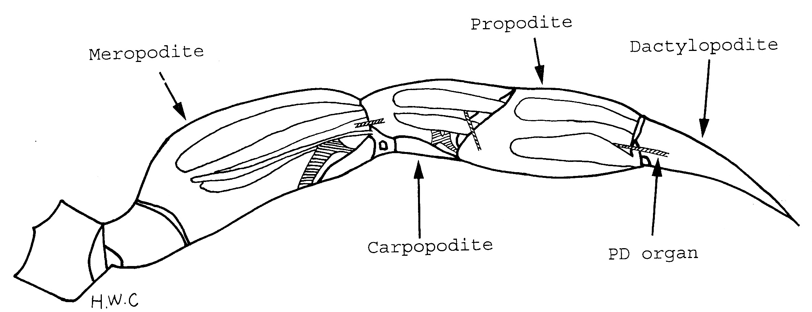

Figure 1: First walking leg of a crab with the tendon shown as an X-ray. The chordotonal organs are the hatched regions.

Since Burke's work in 1953, there has been an active interest in arthropod proprioception. He examined vibration and proprioceptive responses in the PD organ of the crab Carcinus maenas (C. maenas). The gross anatomy of limb proprioceptive organs has been described in the limbs of a variety of crustaceans by Alexandrowicz (1972). The fine structure of the organs was described by Whitear (1962, 1965) and others (Mill and Lowe, 1973). Motor-nerve reflex responses to movement of the joint or to certain chordotonal organs have been investigated (Bush, 1962). However, there has been no attempt to break down the sensory-to-motor nerve reflex from cell to cell while controlling the activity present in the rest of the proprioceptive neurons. Therefore, it is not known which specific cells are responsible for the activity seen in the motor nerves from proprioceptive reflexes.
The anatomical arrangement of chordotonal organs in crabs allows one to analyze each individual neuron according to function (Figure 2). In addition, developmental questions can be addressed as the animal grows or when the animal regenerates a limb (Cooper, 2008; Cooper and Govind, 1991; Hartman and Cooper, 1994).
In this lab, our goal is to record the neural activity that corresponds to joint movement. Before recording, you should state a hypothesis that relates joint movement to PD nerve activity. Then, state what you think will happen to the activity level for the compound you might be testing. In your report, you should discuss whether or not the results support your hypothesis.

The other goal is to use vital dye histological techniques to characterize the anatomy of proprioceptive organs in crab legs. The goal here is to produce an image (with labels) that clearly illustrates the structures involved in proprioception.

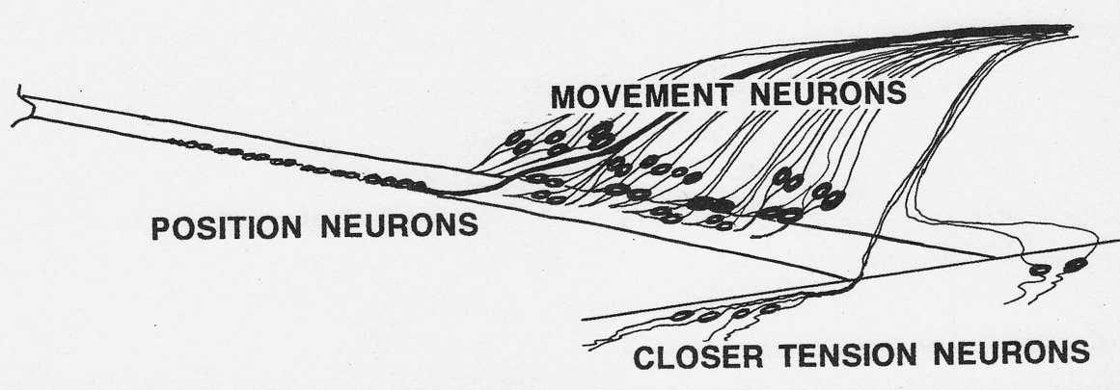
Figure 2: The functional arrangement of the sensory neurons on the PD organ and the tension receptors associated with the closer muscle.

4. Methods
4.1 Materials
1. Faraday Cage
2. Micromanipulator
3. Suction Electrode
4. Dissecting Microscope
5. High Intensity Illuminator (light source)
6. Microscope Platform
7. AC/DC Differential Amplifier (A-M Systems Inc. Model 3000)
8. PowerLab 26T (AD Instruments)
9. Head stage
10. LabChart 7 (ADI Instruments, Colorado Springs, CO, USA)
11. Crab Saline (see Table3)
12. Methylene blue: This is made of crayfish saline at a concentration of 0.25%
13. Sylgard coated dishes (Dow Corning, SYLGARD® 184 silicone elastomer kit; Dow Corning Corporation, Midland, MI. USA)
14. Dissecting tools
15. Insect pins
16. Glass rod/tools for dissecting and manipulating nerves
17. Pipettes and beakers

4.2 Setup

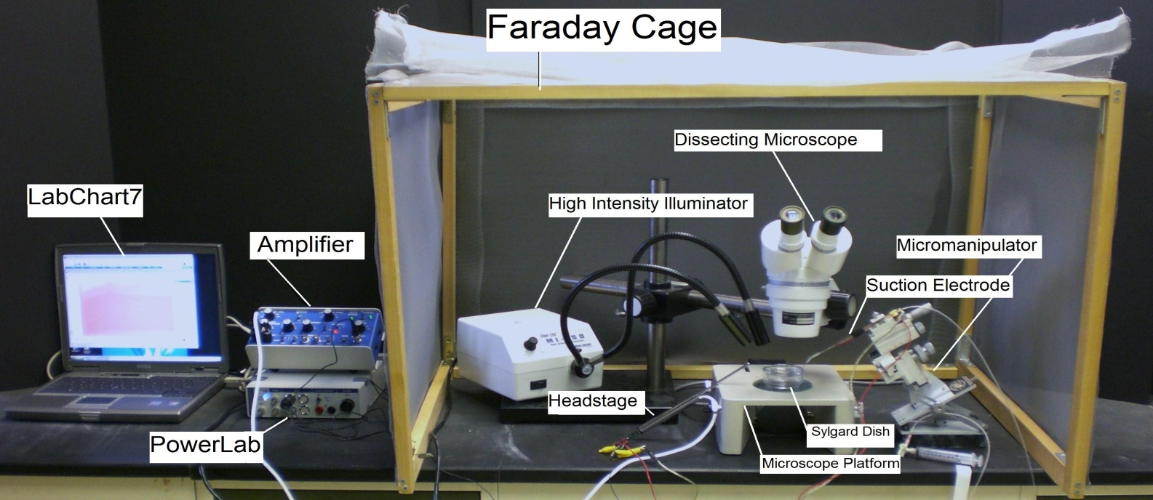
Figure 3: The equipment set up

1. Set up the Faraday cage. The microscope, high intensity illuminator, micromanipulator, and the saline bath will all be set up inside the cage. (The Faraday cage is used to block external electric fields, particularly alternating current, which could interfere with the recording of action potentials).

2. Set up the microscope in a position where it is overlooking the microscope stage.

3. Position the high-intensity illuminator in a convenient position.

4. Place the previously prepared crab saline in the Sylgard dish and position the dish on the stage of the microscope. Staple the dissected leg in the dish.

5. Position the micromanipulator so that the suction electrode has easy access to the saline bath.

6. Suction up saline until it is in contact with the chloride-coated silver wire inside the electrode. Arrange the other wire on the cut side of the suction electrode, close to the tip of electrode, so both wires will contact the saline bath.

7. Connect the AC/DC Differential Amplifier to the Power Lab 26T. Do this by connecting the proper cord from Input 1 on the PowerLab 26T to the output on the amplifier.

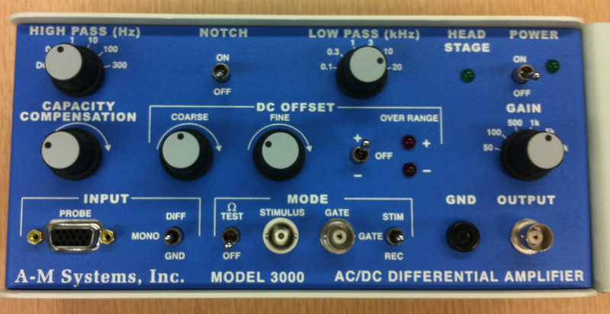

Figure 4: Extracellular amplifier

The settings for the amplifier are as follows:

CONTROL | SETTING
High Pass | DC
Notch Filter | OFF
Low Pass | 20kHz
Capacity Comp. | Counterclockwise
DC Offset Fine and Course knob | Counterclockwise
DC Offset (+OFF) | OFF
Gain knob | 50 (to start with)
Input (DIFF MONO GND) | DIF
MODE(STIM-GATE-REC) | GATE
ΩTEST | OFF

8. Connect the head stage to the ‘input probe’ on the amplifier.

9. Connect the electrical wires from the suction electrode to the head stage. The wires should be connected with the red (positive) at the top left, green (ground) in the middle, and black (negative at the bottom). This is indicated in Figure 4. The ground wire can just be put in the saline bath.

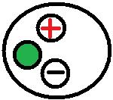
Figure 5: Head stage Configuration

10. Now, connect the USB cord from the PowerLab 26T to the laptop. Ensure that both the amplifier and PowerLab26T are plugged in and turned on before opening LabChart7 on the computer.

11. Open LabChart7.

- The LabChart Welcome Center box will open. Close it.
- Click on Setup
- Click on channel settings. Change the number of channels to 1 (bottom left of box) and push OK.
- At the top right of the chart, set the cycles-per-second to about 10 Kz. Set the volts (y-axis) to about 500 or 200mv.
- Click on Channel 1 on the right of the chart. Click on Input Amplifier. Ensure that the settings – differential, ac coupled, invert (inverts the signal if needed), and anti-alias– are checked.
- To begin recording, press start.

4.3 Dissection
The walking legs of the swimming crab Callinectes sapidus (obtained from http://www.crabplace.com/crabs.asp) or from Cancer magister, found off the northwest coast of the USA, will be used. If the crab is dropped, its carapace will crack and the animal will bleed to death. Therefore, handle them carefully.
Using a net, obtain a crab from the aquarium and place into an empty bucket. While holding the crab with the net or large tongs, across the carapace from behind and, while avoiding the claws, cut across the merus of the second-right walking leg with a stout pair of scissors. The animal will/should autotomize the remaining basal portion of that limb, thus sealing the wound and preventing blood loss. If the crab does not break it off, help it by inserting the scissor tips into the wound and twisting the stump. Return the animal to its aquarium. Put the leg in the Sylgard-lined dissecting dish and cover it with the species-correct cooled (12-19ºC) crab saline.
With scissors, make a cut between the propus and carpus. Discard the carpus and the attached merus. Use Figure 6 to guide you through the rest of this dissection. Cut a large window in the cuticle on the pigmented (anterior) side of the propus using a scalpel with a #11 blade. (Note: Do not cut deeply.) Remove the cuticle layer by sliding the scalpel blade beneath and parallel to the cuticle. This severs the opener and closer muscle fibers attached to the cuticle. Using the same technique, cut a smaller window on the pigmentless (posterior) side of the propus, but leave the condyle attachment intact.
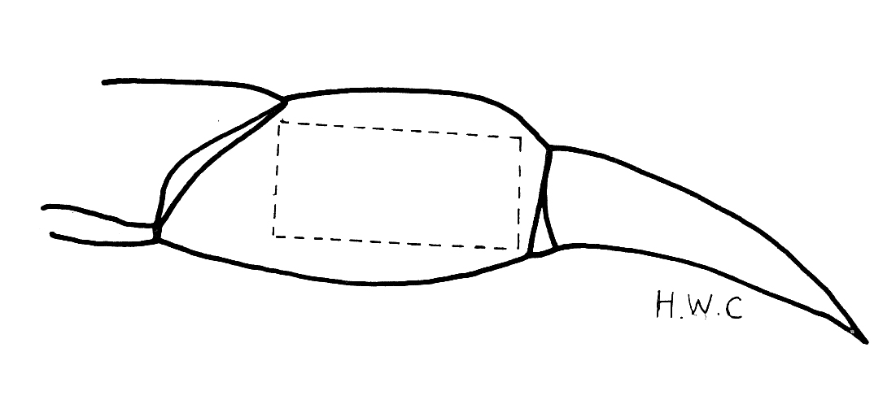

Figure 6: Cut along the dotted line on the propodite

You must exchange the saline in the bath with fresh, cold saline throughout the dissection so that the neurons stay alive. Pin the preparation to the recording dish in the locations illustrated using stainless-steel staples, with the pigmented side facing upwards. For further dissection, place the preparation dish under a dissecting microscope using fiber-optic illumination and transmitted light through the base of the dissection platform to illuminate the prep.
Using sharp-pointed, intermediate-size scissors, carefully cut the opener tendon from its attachment to the dactyl. Be very careful to not disturb the main leg nerve, which should be clearly visible, as you remove and discard the opener muscle and tendon. This will require minimal cutting and trimming.
Locate the PD organ by careful probing with the glass needles. The elastic strand spanning the joint has a silver appearance. Ask for help if you cannot find it. Now, pin the main leg nerve so that the PD organ nerve is exposed (see Figure 7). The fine dissection that follows requires iris scissors. They are only used to cut small, soft tissue. You will receive guidance with this part of the dissection because it is not initially easy. Remove muscle fibers that obscure your view of the organ and its nerve from both sides of the tendon, being very careful not to injure the PD organ or its nerve. Once this has been accomplished, firmly re-attach the preparation to the dish, with the pigment side facing you.
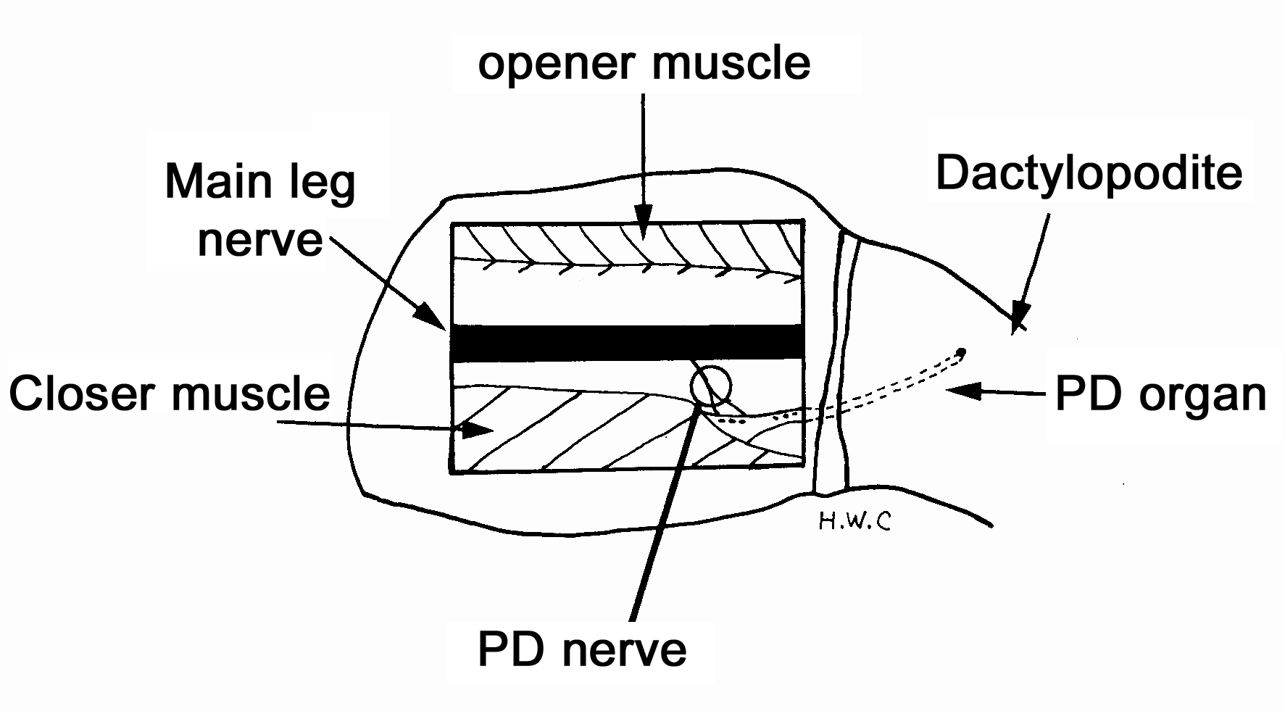
Figure 7: Exposed PD organ and nerve.

Using a fragment of a plastic millimeter ruler, measure and record in your notebook the length of the elastic strand when the dactyl is in the opened and closed positions. Use the attachment points on the protuberance and the tendon as reference markers.
Trace the PD organ nerve in the propus proximally as far as possible in order to free-up a long length of nerve (1.5 cm) for recording purposes. This is best done while the PD nerve is still attached to the main leg nerve for a centimeter or so, since leaving the nerve attached to the main leg nerve adds support. After separating the PD nerve from the main leg nerve with the aid of glass needles, sever the PD nerve proximally using the iris scissors. (Note: Do not stretch or pull on the nerve during the dissection.)

4.4 Recording
You are now ready to determine whether the preparation is still alive. Electrically ground the bath. Change the saline often with saline that has been kept on ice. Turn on the chart recording software. To detect neural activity, draw the cut end of the nerve into the suction electrode.
Move the dactyl throughout opened to closed positions for several cycles using a glass probe. Next, observe activity when the dactyl is pinned in the open, closed, and middle positions. Answer these following questions:

(i) Is there a patterned and consistent response to the opening and closing movements of the dactyl?
(ii) What types of responses are evoked by pinning the dactyl at various fixed positions?
(iii) Is that response consistent when repeated?

Now to collect data for the experiment. Bend the PD joint to 90-degree angle and record for 20 seconds. Move the joint to the stop pin within 1 second and hold the joint in the extended position for 10 seconds. Then, bend the joint back to the 90-degree angle and wait 10 seconds. Repeat 3 times so there are three trials with the same rate and degree of movement. Make sure to include comments in the Chart file for each movement. Now, switch the bathing media to one with the examination compound to examine the effect on neural activity. Repeat the measures as soon as possible. If needed, wait five minutes and repeat the experiment. Then, exchange the bathing media again to saline only. Rinse the bath twice to remove the compound being tested. Repeat the three movements in the fresh saline.

By filling in Table 1 with values, the observations will be easier to make into quantitative statements.

Table 1: Dynamic and Static position. Firing frequency measures from flexed to extended position in three trials (initial saline).

Angle($°)$ | Time of recording | # of Action Potentials in the first 1 second of a 10 second movement | # of Action potentials in the total 10 seconds from the start of the movement
0$°$
(extended)
Trial 1
Trial 2
Trial 3

Repeat the analysis for the experimental compound being tested. Add the data analysis to Table 2.

Table 2: Dynamic and Static position. Firing frequency measures from flexed to extended position in three trials with an experimental compound.

Angle($°)$ | Time of recording | # of Action Potentials in the first 1 second of a 10 second movement | # of Action potentials in the total 10 seconds from the start of the movement
0$°$
(extended)
Trial 1
Trial 2
Trial 3

Table 3: Dynamic and Static position. Firing frequency measures from flexed to extended position in three trials after removing the compound with fresh saline.

Angle($°)$ | Time of recording | # of Action Potentials in the first 1 second of a 10 second movement | # of Action potentials in the total 10 seconds from the start of the movement
0$°$
(extended)
Trial 1
Trial 2
Trial 3

Make careful notes of the observed responses. After you are satisfied with your observations, save the chart file and take a photo of the preparation. Then, move on to further recording from subnerves of the main PD nerve in order to observe the activity of smaller numbers of nerve cells.

You may wish to determine whether the neuromodulators octopamine, serotonin, and proctolin alter the output of the neurons by adding these compounds to the bathing media over the exposed PD organ. Use a pipette and just drip over the preparation (range 10µM to 0.5mM).

4.5 Staining
4.5.1 Methylene Blue:
This older approach of staining neurons does not always stain with the same intensity from preparation to preparation. Vital staining is the staining of cells in the living state. The earliest use of this technique seems to be by Paul Ehrlich (1885), who immersed fresh tissue in methylene blue. Methylene blue chloride (MBC) is now used as a nuclear stain for histology, as a bacterial stain, and in combination with eosin as a blood stain. It is an excellent, if capricious, stain for identifying neurons. Methylene blue chloride is theoretically tetramethylthionin (Lillie, 1969).
There is a great deal of witchcraft surrounding the use of MBC. For instance, a fresh methylene blue chloride solution is not a good stain; it is better to use a solution that is "ripened" (i.e., one that has been sitting around in a bottle for a few years!). Ripening forms the oxidation products azure A and azure B. Nontoxic to nervous tissue when applied topically, methylene blue chloride stains neurons a dark blue but fades and becomes colourless in the absence of oxygen or in the presence of bright light.
The tissue needs to be exposed as thoroughly as possible for the neurons to be stained. Pin the preparation in a small Sylgard bottom glass Petri dish using pieces of insect pins. Arrange the preparation so that it will be in its normal geometry.
The methylene blue chloride that you will use is a product of the following process. It is Methylene Blue (Basic Blue 9, C.I. 52015) obtained from Matheson Co., Inc. The stock is prepared by making a 0.25% solution of methylene blue chloride in warm distilled water, then by refrigerating the solution overnight. While cold, this solution is filtered twice through Whatman Filter Paper # 1. This stock is ripened by putting the bottle on the shelf and forgetting about it for a year or two.
When one is ready to stain a preparation, dilute one part methylene blue chloride stock solution with two parts of distilled water. Add this mixture to five parts of buffered saline. Thoroughly irrigate the area of interest. Incubate the preparation at 12-13°C. Examine the prep every 10-15 minutes with the dissecting microscope using low intensity illumination to follow the progress of the staining. In some cases, staining will be completed in an hour; in others, it may take overnight. When you are satisfied that the neurons are stained well, replace the stain solution with cold saline. Keeping the prep cold and illuminating it only when necessary will help the staining last for several hours. Particularly good preps may be photographed or sketched out. Figure 8 shows a photo taken with an I-Phone 4, with the settings on high resolution, through the eye piece of a dissecting microscope. A higher magnification of Figure 8 is presented in Figure 9. This was magnified with a higher objective through the microscope and not a digital zoom of the I-Phone. This figure is labeled to point out a tension neuron that is close to the apodeme as well as to demarcate the elastic strand of the chordotonal organ. Draw or photograph your preparation. Describe the organization of the PD organ.
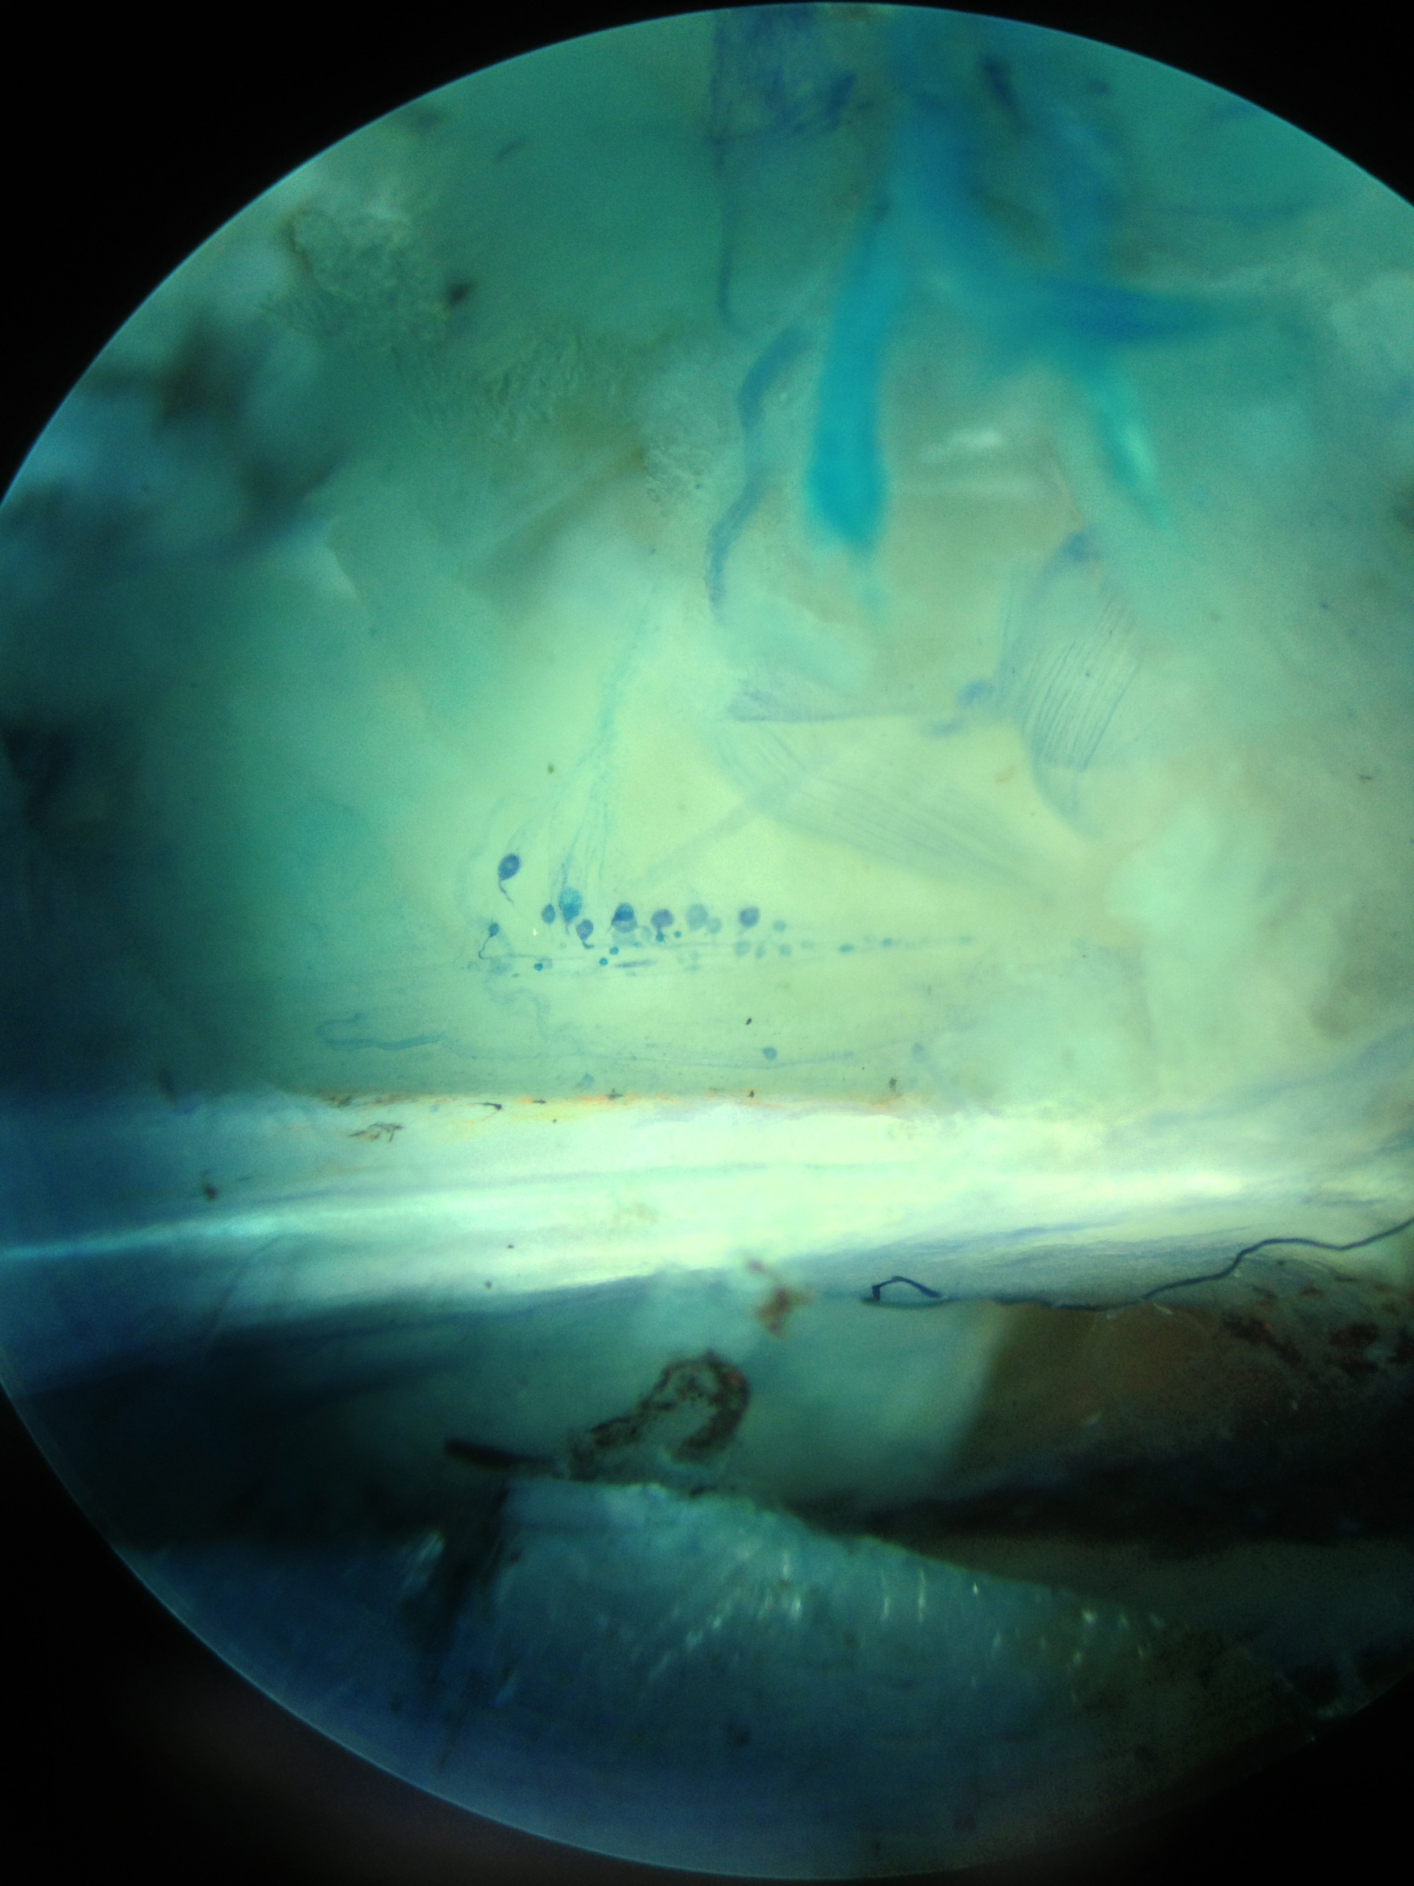
Figure 8: Photo taken with an I-Phone 4 camera through the eyepiece of a microscope showing the apodeme (i.e., tendon) that is bright, white, and horizontal in the photo. The PD chordotonal neurons are slightly stained with methylene blue. Closer muscle is observed in the background.
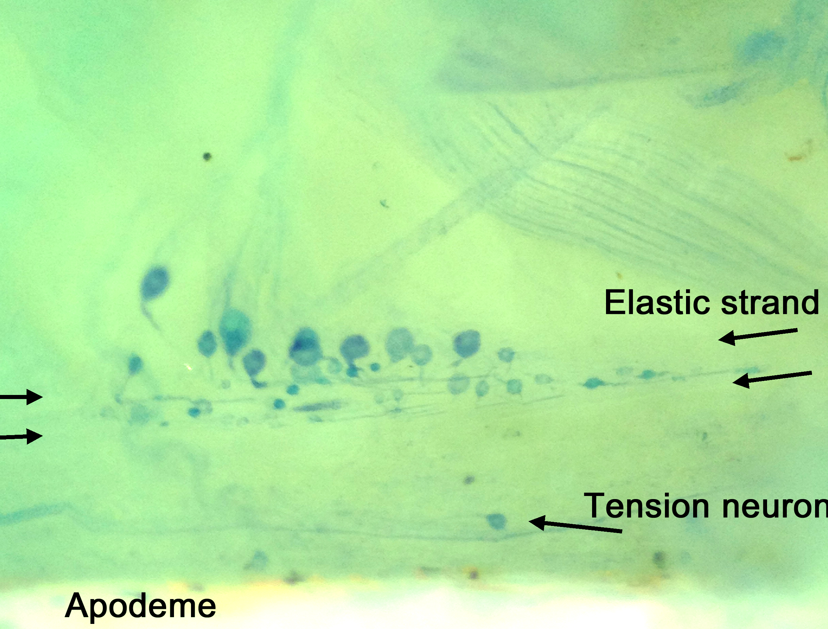
Figure 9: Photo taken with an I-Phone 4 camera through the eyepiece of a microscope with a higher resolution than shown in figure 8. The individual somas of the neurons are shown with the sensory endings projecting into the elastic strand. Close to the apodeme, a tension neuron is shown. The neurons are slightly stained with methylene blue.

4.5.2. 4-di-2-ASP:
Fluorescent dyes can also be used to back-fill the PD neuron; however, a microscope with capabilities to view the fluorescent stain is required. Use the same approach as described above for methylene blue staining. Use a 10 µM concentration of 4-Di-2-ASP solution and leave the preparation in the refrigerator for 15 minutes. This fluorescent dye does fade relatively quickly, so photograph the preparations quickly and avoid overexposure to the mercury light (Figure 10). If one has a high enough magnification, the sensory endings can be seen inside the supportive scolopales (Whitear, 1962,1965; Hartman and Cooper, 1994; Figures 11-13).
Figure 10: A back-fill of the PD nerve in Cancer magister with 4-Di-2-ASP.

Figure 11: Higher magnification of neurons shown in Figure 14. The PD nerve in Cancer magister was back-filled with 4-Di-2-ASP.

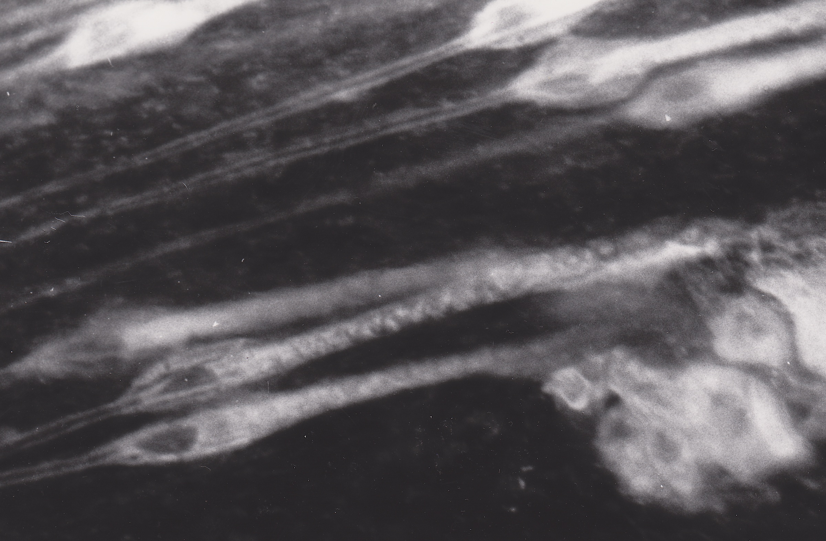

Figure 12: Movement sensitive sensory endings in the PD organ of Cancer magister.
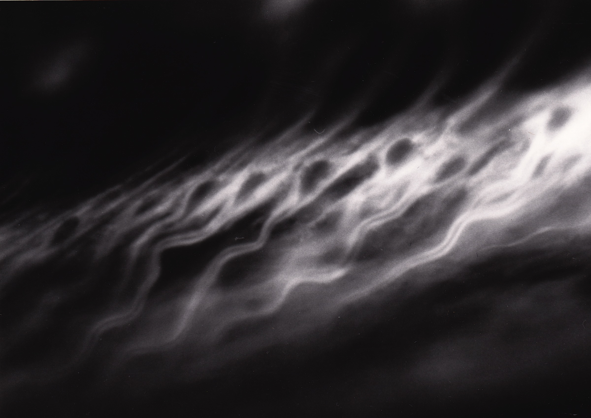
Figure 13: Sensory endings of position cells in the distal end of the PD organ in Cancer magister

5. Results
In order to understand the basic anatomy of the propus and its contained muscles, tendons, motor and sensory neurons, it is best to stain the preparation as indicated in the Methods section. Once familiar with the anatomy, physiological recordings can be attempted on unstained preparations. By adjusting the light source intensity and angle, you can optimize your view of the main leg nerve and locate the small branch leading to the PD organ. Figure 14 illustrates the ventral bundle separated from the main leg nerve.
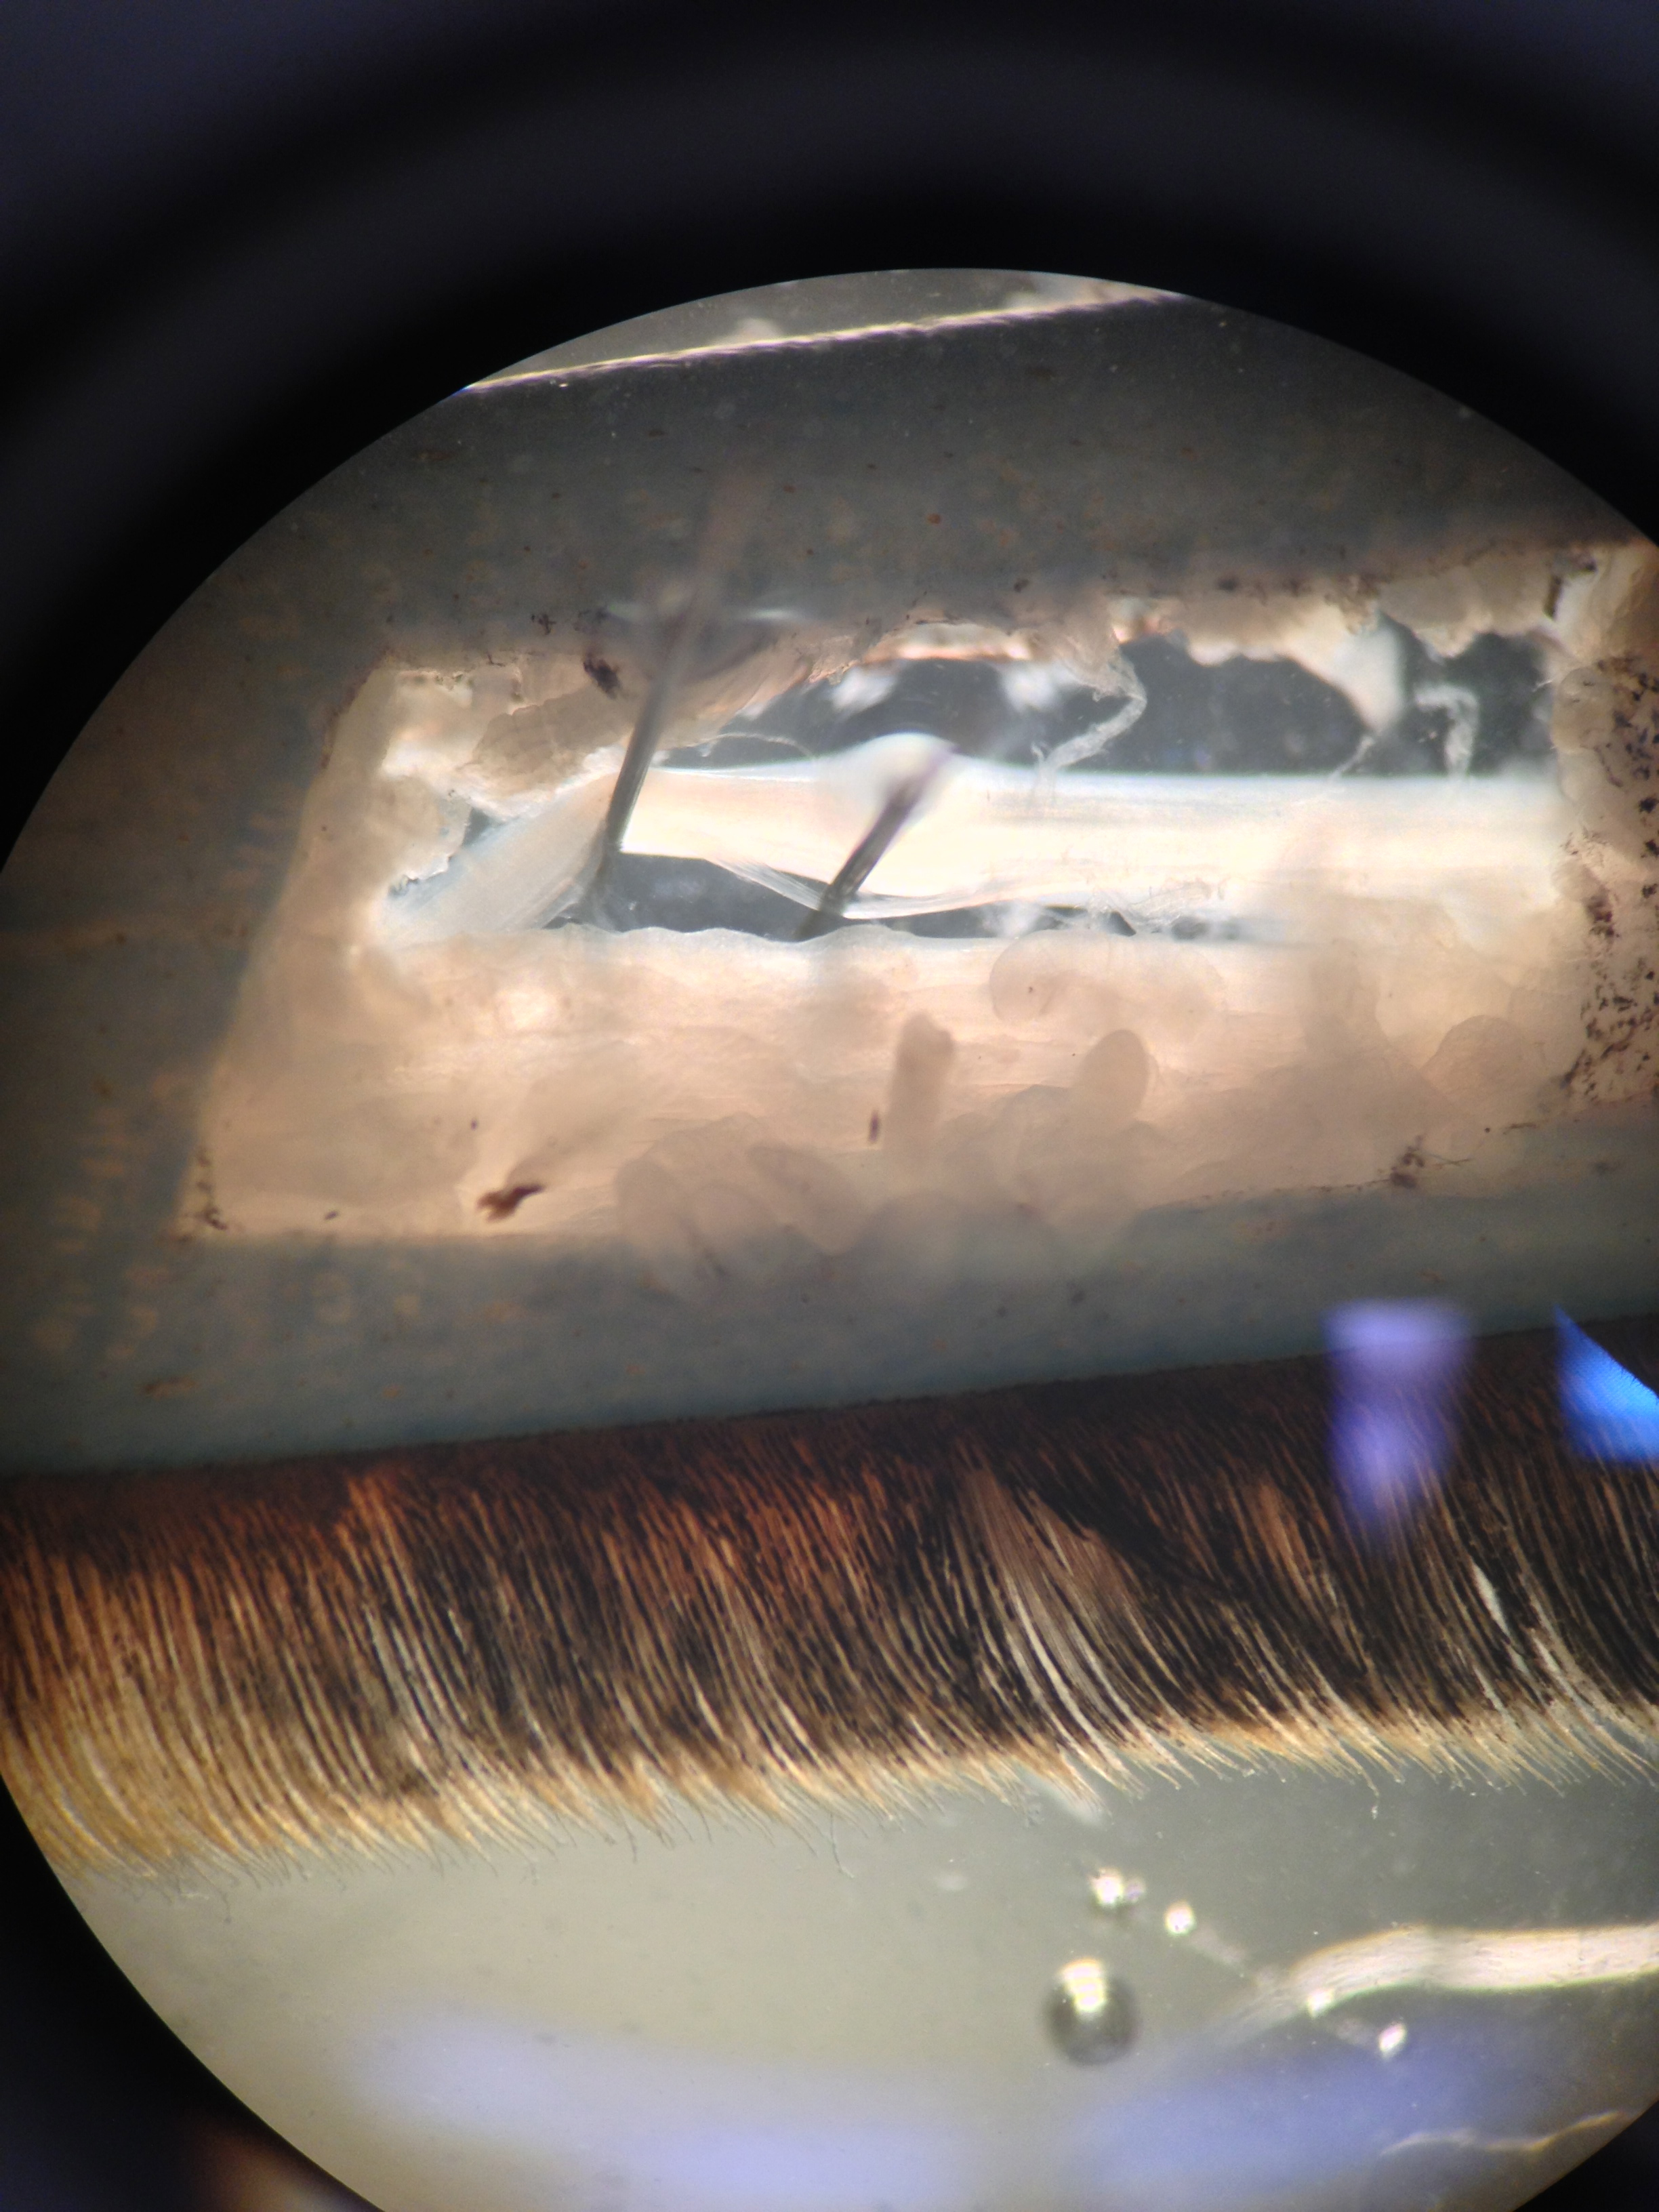
Figure 14: The ventral most bundle of the main leg nerve is isolated and leads to the PD organ.

Representative recording of extracellular spikes obtained while moving the dactyl rapidly to 0 degrees (fully extended joint) and back to the closed (fully flexed joint) position (90 degrees) is shown in Figure 15. Note that a fully extended joint is a relaxed position for the muscle and a fully flexed joint is a full stretch or extension of the opener muscle. The movement evokes a response during displacement and, when the dactyl is held in a position, there is tonic firing of other usually smaller neurons (Figure 16). If the joint is next moved from either 0 degrees (or 90 degrees) to 45 degrees, there is again firing during the movement and tonic activity at that position. Next, move the dactyl at various velocities and observe neuron activity depending on the rate of movement. That accomplished, pin the dactyl at various angles (0, 15, 30, 45, 60, 75 and 90 degrees) and note tonic activity (Figure 17).

Figure 15: Rapid open and closing from fully flexed to extended (90 to 0 degrees) position).

Figure 16: Hold at 0 degrees. There are some tonic spikes present.

Figure 17: Move the dactyl rapidly to 45 degrees and then return it to flexed (closed) position.

6. Discussion
The neurons of chordotonal organs are of two specific functional types: those that respond to movement and those that respond to static positions. Single cell recordings from a variety of chordotonal organs, no matter which joint is examined, have shown this to be the case (Cooper, 2008; Hartman and Boettiger, 1967). Indeed, chordotonal organs associated with the antennal joints of lobsters reveal the same two sensory types and basic anatomy (Hartman and Austin, 1972). In addition to there being two neuron types (movement and position), the neurons share the same anatomical arrangement on their respective elastic strands. The large somata located proximally on the strand tend to belong to the dynamic movement-sensitive neurons; the neurons signaling static positions by firing tonically have small somata and are located distally (Figure 18).

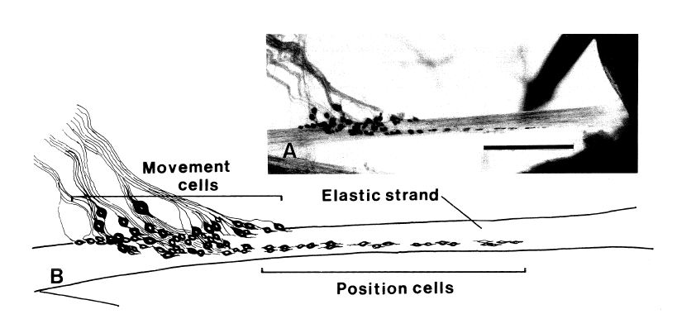

Figure 18: A representation of the neuronal types associated with a PD chordotonal organ.

In mapping out the function of individual neurons in other chordotonal organs (MC1, MC2, CP1, and CP2) within the walking legs of Cancer magister, an interesting observation was made; specifically, neuronal function seems to be related to the location of the single sensory ending on each elastic strand, as well as to the size of its soma (Cooper, 2008). Such an arrangement was also shown for the PD organ in Cancer irroratus years earlier by Hartman and Boettiger (1967). It is interesting that the PD joint only contains a single chordotonal organ while there are two chordotonal organs in the carpus-propodus and merus-carpus joints. Also, the shapes of the chordotonal organs vary, with the MC1 and CP1 organs being planar while the MC2, CP2 and PD organs are both rod-shaped. It is unclear whether this differential arrangement of chordotonal organs have a special function.

Future experimentation with the joint chordotonal organs would be interesting exploration, especially to examine the structural and physiological profiles during leg regeneration in various species at different life-cycle stages as a follow-up to an initial study on this subject in Cancer magister (Hartman and Cooper,1994). An adult that regenerates a leg might do so more slowly than a younger crab. Questions to follow up on are: Is there as even of a distribution and organization depending on the age of the animal when regenerating a limb? Are the axonal projections to the CNS (ventral nerve cord) in a regenerating limb functional, or does it take time and joint use to establish functional connections? What happens to the severed axons proximal to the autotomy plan when the limb is autotomized? Some of the severed axon fragments may be able to synapse with the regenerating axons in a newly formed limb (Cooper, 1998).

One interesting aspect of regenerating crustacean limbs is that the cell bodies of the motor neurons remain in the ventral nerve cord/CNS and they send out their projections to the newly formed muscles. However, the sensory neurons develop out in the regenerating limb and send their axons into the ventral nerve cord/CNS, locating the correct synaptic connections via their previous sensory neurons. As the limb regenerates with each molt, there are more sensory neurons added to the chordotonal organs and they also have to make connections in the CNS. In normal development of the animal’s motor neuron and interneurons, the circuits are being established in coordination with the sensory projections. However, in a regenerating limb, new sensory neurons are connecting to an established motor neuron circuit and dendritic tree. It would be interesting to know whether the motor neurons prune back the dendritic tree after a leg is autotomized, or if it remains in its full arborization while waiting for the regeneration sensory axons to re-form synaptic communication.

As one can imagine, there are many questions still unanswered regarding cordotonal organs. There are a number of neuromodulators and peptides known to be present in crustacean hemolymph. It would also be interesting to know whether these have any differential impact on the firing rate or responsiveness of these primary sensory neurons for static, position-sensitive neurons versus dynamic, movement-sensitive neurons. Additionally, it would be interesting to investigate how modulators work, not only on the sensory neurons but also regarding actions within a coordinated motor circuit, in systems ranging from invertebrates to higher mammals (Dasari & Cooper, 2004; Marder & Thirumalai, 2002; Rossignol et al., 2001, 2002; Strawn et al., 2000).
Another fascinating area of physiological study would be evaluating environmental conditions of varying temperature in which crustaceans live, since they are generally conformers to the surrounding temperature. It is not fully understood how coordination within a neural circuit is maintained as the neurons alter activity under temperature change. A slow rate of change might allow the animal some time for acclimatization, whereas a rapid change may not (Chung et al., 2012). Physiological changes in pH or osmolarity due to metabolism, behavior (Cooper et al., 2011), or environmental impact would be interesting to study with well-defined sensory neurons, especially those within the cordotonal organs, since their function is well-characterized at a single cell level.

REFERENCES:

Alexandrowicz, J.S. (1972) The comparative anatomy of leg propriocetors in some decapod Crustacea. J. Mar. Biol. Ass. UK 52:605-634
Burgess, P.R., Wei, J.Y., Clark, F.J., and Simon, J. (1982) Signaling of kinesthetic information by peripheral sensory receptors. Ann. Rev. Neurosci. 5:171-187
Burke, W. (1953) An organ for proprioception and vibration sense in Carcinus maenas. J. Exp. Biol. 31:127-138
Bush, B.M.H. (1962) Proprioceptive reflexes in the legs of Carcinus maenas. J. Exp. Biol. 39:89-105
Bush, B.M.H. (1965a) Proprioception by chordotonal organs in the mero-carpopodite and carpo-propodite joints of Carcinus meanas legs. Comp. Biochem. Physiol. 14:185-199
Bush, B.M.H. (1965b) Proprioception by the coxo-basal chordotonal organ, CB, in legsä of the crab, Carcinus maenas. J. Exp. Biol. 42: 285-297.
Chung,Y-S. Cooper, R.M., Graff, J. and Cooper, R.L. (2012) The acute and chronic effect of low temperature on survival, heart rate and neural function in crayfish (Procambarus clarkii) and prawn (Macrobrachium rosenbergii) species. Open Journal of Molecular and Integrative Physiology 2:75-86.
Cooper, R.L. (2008) Mapping proprioceptive neurons on chordotonal organs in the crab, Cancer magister. Crustaceana 81(4):447-475.
Cooper, R.L. (1998) Development of sensory processes during limb regeneration in adult crayfish. Journal of Experimental Biology 201:1745-1752
Cooper, R.L. and Govind, C.K. (1991) Axon composition of the proprioceptive PD nerve during growth and regeneration of lobster claws. Journal of Experimental Zoology 260:181-193.
Cooper, R.L. and Hartman, H.B. (1994) Responses of the bender apodeme tension receptors in the Dungeness crab, Cancer magister. Comparative Biochemistry and Physiology 109A:479-486.
Cooper, R.L. and Hartman, H.B. (1989) Effects of neuromodulators on proprioceptive neurons in the limbs of the crab, Cancer magister. Soc. Neurosci. 15:565.
Cooper, R.M., Schapker, H. Adami, H. and Cooper, R.L. (2011) Heart and ventilatory measures in crayfish during copulation. Open Journal of Molecular and Integrative Physiology 1(3):36-42.
Dasari, S. and Cooper, R.L. (2004) Modulation of sensory–CNS–motor circuits by serotonin, octopamine, and dopamine in semi-intact Drosophila larva. Neuroscience Research 48:221-227.
Hartman, H.B. (1985) Tension receptors on the closer muscle apodeme in the walking legs of the blue crab Callinectes sapidus. J Comp Physiol 157:355-362
Hartman, H.B. and Austin, W.D. (1972) Proprioceptor organs in the antennae of Decapoda Crustacea. J. Comp. Physiol. 81: 187-202.
Hartman, H.B., and Boettiger, E.G. (1967) The functional organization of the propys-dactylus organ in Cancer irroratus Say. Comp. Biochem. Physiol. 22:651-663
Hartman, H.B. and Cooper, R.L. (1994) Regeneration and molting effects on a proprioceptor organ in the Dungeness crab, Cancer magister. J. Neurobiology 25:461-471.
Hartman HB, Johnson EE, and Storer PD (1997) Manipulation by the crab claw is dependent upon chordotonal organ afference. J.Exp. Zool. 280:215-221
Macmillan, D. L. and Dando, M.R. (1972). Tension receptors on the apodemes of muscles in the walking legs of the crab, Cancer magister. Mar. Behav. Physiol., 1: 185-208.
Marder, E., Thirumalai, V., 2002. Cellular, synaptic and network effects of neuromodulation. Neural Networks. 15, 479–493.
Mill, P.J., and Lowe, D.A. (1973) The fine structure of the PD proprioceptor of Cancer pagurus. I. The receptor strand and the movement sensitive cells. Proc. R. Soc. Lond. B 184:179-197
Pitman RM, Tweedle CD, Cohen MJ. (1972). Branching of central neurons: intracellular cobalt injection for light and electron microscopy. Science. 176(4033):412-4.
Rossignol, S., Giroux, N., Chau, C., Marcoux, J., Brustein, J., Reader, T.A., 2001. Pharmacological aids to locomotor training after spinal injury in the cat. J. Physiol. 533, 65–74.
Rossignol, S., Bouyer, L., Barthelemy, D., Langlet, C., Leblond, H., 2002. Recovery of locomotion in the cat following spinal cord lesions. Brain Res.—Brain Res. Rev. 40, 257–266.
Strawn, J.R., Neckameyer, W.S., and Cooper, R.L. (2000) The effects of 5-HT on sensory neurons, central, and motor neurons driving the abdominal superficial flexor muscles in the crayfish. Comparative Biochemistry and Physiology B 127:533-550.
Vedel, J. P., Clarac, F., Combined reflex actions by several proprioceptive inputs in the rock lobster walking legs. J. Comp. Physiol. 130, 251-258 (1979).
Whitear, M. (1962) The fine structure of crustacean proprioceptors. I. The chordotonal organs in the legs of the shore crab, Carcinus meanas. Phil. Trans. R. Soc. Lond. B 245:291-325
Whitear, M. (1965) The fine structure of crustacean proprioceptors. II. The thoracico-coxal organs in Carcinus, Pagurus and Astacus. Phil. Trans. R. Soc. Lond. B 248:437-462
Wiersma, C.A.G. (1959a) Movement receptors in decapod crustacea. J. Mar. Biol. Ass. UK 38:143-152
Wiersma, C.A.G., and Boettiger, E.G. (1959b) Unidirectional movement fibres from a proprioceptive organ of the crab, Carcinus maenas. J. Exp. Biol. 36:102-112.

Solution for C. sapidus saline (Blundon 1989, J. Comp. Physiol B 158: 689-696)

SALT g/l g/2l g/3l
NaCl 27.47 54.94 82.41
KCl 0.59 1.18 1.77
MgCl₂ 6H₂0 1.421 2.842 4.269
CaCl₂ 2H₂0 2.205 4.41 6.615
Dextrose 1.982 3.964 5.945
HEPES acid (5mM) 1.19 2.38 3.57
HEPES salt (5mM) 1.30 2.60 3.90
Adjust to pH 7.5 with NaOH or HCl.
With an osmotic pressure of 1000 mm/l.

Solution for C. magister saline (Macmillan & Dando, 1972; Hartman and Cooper, 1994)
SALT g/l
NaCl 27.29
KCl 0.81
MgSO₄ 7H₂0 4.81
CaCl₂ 2H₂0 1.85
Na₂SO₄ 10H₂0 0.97
Dextrose 1.982
HEPES acid 0.476
HEPES salt 2.08
Adjust to pH 8.1 with NaOH or HCl.

